ITC encompasses technologies for managing, processing, transmitting, and exchanging data. It include hardware, software, network, and application crucial for collecting, storing, processing, and disseminating information. ICT integrates telecommunications, multimedia, audio-visual processing, and intelligent building systems, facilitating seamless information flow across platforms and devices. This field is fundamental to modern societies, impacting sectors like business, education, healthcare,..

Information and communication technologies

TECHNOLOGIES RELATED TO TIC

FINAL

PROJECT

# Content table :

|  |  |  |
| --- | --- | --- |
| Title | | **Page** |
| What is information and communication technologies (ITC)? | | **Page 2** |
| The different technologies related to ICT | 1*Networking technologies.  2*Internet technologies.  3*Cloud computing.  4*Data storage and management.  5*Cybersecurity technologies.  6*Artificial intelligence.  7*Internet of things. | **Page 3** |
| 8*Unified communication.  9*Mobile technologies.  10*Web development technologies.  11*Big data technologies.  12*Virtualization technologies.  13*Augmented reality and virtual reality.  14*Biometric technologies.  15*Blockchain and distributed ledger technologies. | **Page 4** |
| 16*Google services. | **Page 5** |
| 17*Microsoft tools. | **Page 6-7** |
| 18*Git. | **Page 8** |
| 19*GitHub. | **Page 9** |
| Conclusion | | **Page 10** |

INFORMATION AND COMMUNICATION TECHNOLOGIES

**What is information and communication technology?**

Information and communication technologies is defined as a diverse set of technological tools and resources used to transmit ,store ,create ,share or exchange information.

ICT plays a profound role in any business growth . It improves employee communication, automates many business operations , and enhances the transparency of your projects.

ICT encompass a broad range of technologies used to handle telecommunication, broadcast media, audio visual processing, and network-based control and monitoring applications. Key components include computers, software, networks, and various digital devices. ICT plays a vital role in enhancing connectivity, enabling data transfer, and fostering communication across the globe. The evolution of ICT has led to advancements such as the internet mobile communication, and cloud computing, shaping the way we live and work. Ongoing developments, including 5G network, artificial intelligence, and the internet of things, continue to drive innovation in this dynamic field.

**The different technologies related to ICT :**

1. **Networking technologies:**

* Ethernet
* Wi-Fi
* Bluetooth
* 5G and other mobile network generation

1. **Internet technologies:**

* Hypertext transfer protocol(HTTP)
* Transmission Control Protocol (TCP)/Internet Protocol (IP)
* Domain name system(DNS)
* Web browsers

1. **Cloud computing:**

* Infrastructure as a Service (IaaS)
* Platform as a Service (PaaS)
* Public, Private, and Hybrid Clouds

1. **Data Storage and management:**

* Databases(e.g., MySQL, Oracle, MonogoDB)
* Data Warehousing
* Data mining
* Distributed File Systems

1. **Cybersecurity Technologies:**

* Firewalls
* Antivirus Software
* Encryption Technologies
* Intrusion Detection Systems(IDS)

1. **Artificial Intelligence(AI) and machine learning (ML):**

* Natural Language Processing (NLP)
* Computer Vision
* Neutral Networks
* Machine Learning Algorithms

1. **Internet of Things (loT):**

* Sensor Technologies
* Communication Protocol (e.g., MQTT, CoAP)
* Edge Computing

1. **Unified Communication :**

* Voice over IP (VolP)
* Video Conferencing
* Instant Messaging

1. **Mobile Technologies :**

* Mobile Operating Systems (Android , IOS)
* Mobile App Development
* Mobile Device Management(MDM)

1. **Web Development Technologies :**

* HTML, CSS, JavaScript
* Front-end and Bach-end Frameworks (React, Angular, Node.js)
* APIs (application programming interfaces)

1. **Big data technologies:**

* Hadoop
* Apache Spark
* NosQL Databases (Cassandra, HBase)

1. **Virtualization Technologies :**

* Virtual Machines (VMs)
* Containers (Docker)
* Virtualization Platforms (VMware, VirtualBox)

1. **Augmented Reality (AR) and Virtual Reality (VR):**

* AR Development Kits
* VR Headsets
* Spatial Computing

1. **Biometric Technologies:**

* Fingerprint Recognition
* Facial Recognition
* Iris scanning

1. **Blockchain and Distributed Ledger Technologies:**

* Cryptocurrencies (Bitcoin, Ethereum)
* Smart Contracts
* Decentralized Applications (DApps)

These technologies collectively contribute to the diverse and ever-evolving field of ICT, shaping the way information is processed, communicated, and utilized in various domain.

1. **Google Services:**

Google services are closely related to ICT . These services leverage technology to facilitate communication, information access, and collaboration in the digital realm . Google employs various ICT components such as cloud computing, data storage, networking, and software applications to deliver its services. For instance:

|  |  |
| --- | --- |
| **Google search:** | Relies on sophisticated data algorithms and data indexing, demonstrating information retrieval technology. |
| **Gmail:** | Utilizes email protocols and communication technologies to enable efficient electronic messaging. |
| **Google Maps:** | Incorporates GPS technology and mapping algorithms for location-based services. |
| **Google Drive:** | Is cloud storage service, showcasing advancements in data storage and retrieval. |
| **Google Docs, Sheet and Slides:** | Leverage cloud-based collaboration, demonstrating online document processing and real-time collaboration capabilities. |
| **Google Chrome:** | Represent web browser technology. |
| **Google Translate:** | Showcases natural language processing and machine translation technologies. |
| **Google Assistant:** | Employs artificial intelligence and voice recognition technology for virtual assistance. |

These services collectively illustrate the integration of various ICT technologies in creating a comprehensive digital ecosystem, enhancing user experiences and connectivity.

Google services. 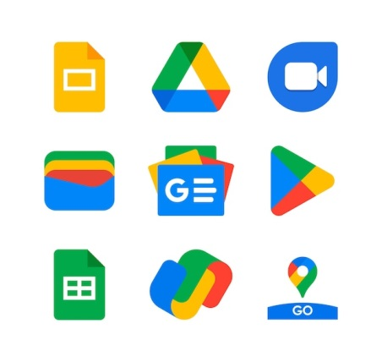

1. **Microsoft tools:**

Microsoft tools encompass a variety of technologies closely related to information and communication Technologies. Microsoft offers a broad range of software and services that play significant roles in areas such as productivity, communication , and data management . Some key Microsoft technologies include:

* + 1. **Microsoft Office Suite:**
* Microsoft word
* Microsoft excel
* Microsoft PowerPoint
* Microsoft Outlook
  + 1. **Windows Operating system:**
* Windows 11 and previous versions for personal computers.
* Windows server for server environment.
  + 1. **Microsoft Azure:**
* Cloud computing platform providing services like virtual machines, databases, and AI.
  + 1. **Microsoft 365:**
* Cloud-based productivity suite combining office applications with cloud swrvices.
  + 1. **Microsoft Teams:**
* Collaboration platform for chat, video conferencing, file sharing, and project management.
  + 1. **Azure DevOps:**
* Tools for development, testing, and deployment of software.
  + 1. **Power Platform:**
* Tools for building custom apps (Power Apps), automating workflows (Power Automate), and analyzing data (Power BI).
  + 1. **SQL Server:**
* Relational database management system for data storage and management.
  + 1. **Visual Studio:**
* Integrated development environment (IDE) for software development.
  + 1. **Dynamics 365:**
* Suite of business applications for customer relationship management (CRM) and entreprise resource planning (ERP).
  + 1. **PowerShell:**
* Task automation framework and scripting language.
  + 1. **Skype for Business:**
* Communication platform for instant messaging, audio, and video conferencing.

These Microsoft tools and technologies contribute to the overall ICT landscape , addressing various needs in business , development , collaboration , and data management . They showcase Microsoft’s impact on shaping the digital infrastructure and communication technologies used by individuals and organizations worldwide.

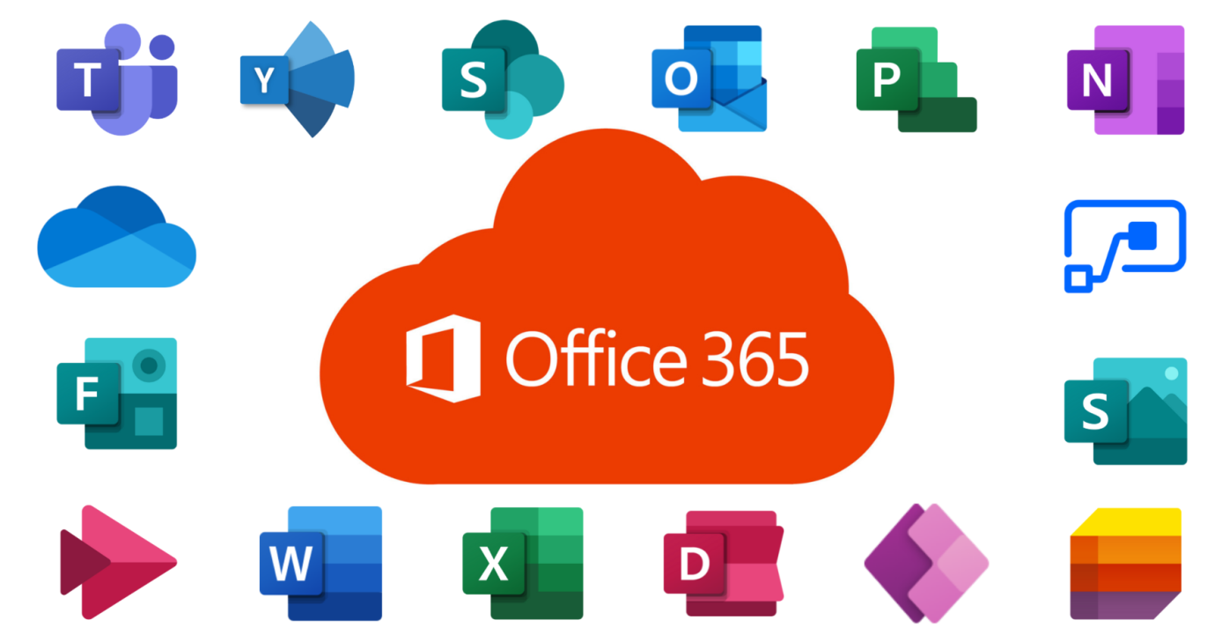

1. **Git:**

Git is distributed version control system designed for tracking changes in source code during software development . It allows multiple developers to collaborate on projects efficiently by managing the history of changes , merging different branches, and facilitating code sharing.

Key aspects of how Git related to ICT include:

* **Version Control:** Git enables developers to keep track of changes made to source code over time , providing a systematic way to manage and document modifications.
* **Collaboration:** It supports collaboration among distributed teams, allowing developers to work on the same codebase concurrently. Changes can be merged seamlessly, promoting efficient teamwork.
* **Branching and merging:** Git allows developers to create branches for different features or bug fixe. This branching model make it easier to work on independent tasks and merge changes back into the main codebase.
* **Code sharing:** Developers can easily share their code with others using Git repositories hosted on platforms like GitHub, GitLab or Bitbucket. This fosters open source contributions and collaborative development.
* **Backup and recovery:** Git provides a reliable backup mechanism, allowing developers to revert to previous versions in case of errors or unforeseen issues.
* **Integration with development tools:** Git integrates with various development tools , build systems , and continuous integration / delivery (CI/CD) pipelines, contributing to the automation of software development processes.

In summary, Git is a fundamental tool in the realm of software development within ICT , contributing to efficient collaboration , version control , and code management practices.

1. **GitHub:**

GitHub is a web-based platform that utilizes Git for version control and offers a collaborative environment for software development projects. It plays a significant role in the ICT landscape for several reasons:

* **Code Hosting and Repositories:** GitHub provides a platform for hosting Git repositories . Developers can store , share , and collaborate on code projects, making it a central hub for version-controlled source code.
* **Collaborative Development:** GitHub facilitates collaboration among developers by offering features like pull requests, code reviews, and issue tracking . This enables teams to work together on projects , contributing code and providing feedback in a structured manner.
* **Open Source Community:** Many open-source projects use GitHub as a hosting platform . Developers from around the world can contribute to projects , report issues , and propose changes , fostering a global collaborative community.
* **Project Management:** GitHub includes project management features, such as boards and milestones , to help teams organize and track their work. This enhances the overall project management capabilities within the ICT domain.
* **Integration with CI/CD:** GitHub integrates seamlessly with various continuous integration and continuous deployment(CI/CD) tools. This integration automates build and deployment processes, contributing to efficient software development workflows.
* **Documentation:** GitHub supports documentation through its wiki feature and enable developers to maintain project documentation alongside the code . This is crucial for knowledge sharing and maintaining project information.
* **Issues and Bug Tracking:** Developers can use GitHub to report issues, track bugs , and discuss potential improvement . This enhances communication and transparency within development projects.
* **Education and Learning:** GitHub is used in educational setting to teach version control and collaborative development practices . It serves as a practical platform for learning software development.

In summary, GitHub is a key platform within the ICT ecosystem, providing tools and features that enhance collaboration, version control, and project management for software development.

**Conclusion:**

Information and communication technologies (ICT) encompass a diverse range of tools, from foundational elements like networks and internet protocols to cutting-edge developments such as artificial intelligence . Major players like Google and Microsoft offer a wide range of services , while tools like Git and GitHub revolutionize code management and collaboration in software development . Constantly evolving , these technologies shape how we communicate, work, and interact with information on a daily basis.

